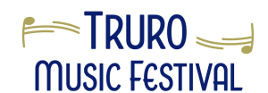

Donor Form

Truro Music Festival
605 Prince St
Truro, Nova Scotia B2N 1G2
E-mail: Donation@TruroMusicFestival.ca
We would be thrilled if you would like to contribute financially to the Truro Music Festival. You are welcome to make a single or yearly donation, or to sponsor an annual award.

The Festival is a registered non‐profit charitable organization*, and all donations are tax‐deductible – official tax receipts will be issued for your donation.

If your business is interested in advertising as a corporate sponsor, please contact our advertising chair through info@truromusicfestival.ca .

Please complete this form and mail it with your donation to the address above or by email; we are happy to answer any questions you might have at any time.

Name:
Mailing address (for tax receipt):
Phone:
Email:
Donation Amount:
How should your name be listed in the Final Concert Program? | I wish to remain anonymous  Name:
Optional: I would like further information about sponsoring an award through either a yearly donation or an endowment.

The Truro Music Festival would like to thank you very much for your donation and continued support.

