Class # # |  |  | Class # # |  |  | Class # #
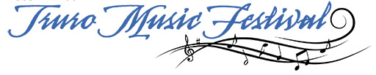  Own Choice Form |  |  | Own Choice Form |  |  | Own Choice Form
Entrant Name: |  |  | Entrant Name: |  |  | Entrant Name:
Phone# |  |  | Phone# |  |  | Phone#
Teacher Name: |  |  | Teacher Name: |  |  | Teacher Name:
Phone #: |  |  | Phone #: |  |  | Phone #:
Class #: |  |  | Class #: |  |  | Class #:
Class Name: |  |  | Class Name: |  |  | Class Name:
Selection Title: |  |  | Selection Title: |  |  | Selection Title:
Composer: |  |  | Composer: |  |  | Composer:
Page #: |  |  | Page #: |  |  | Page #:
*OWN CHOICE music must be clearly marked. Fill out and attach this form to your “Own Choice” music and pass it to the music desk 15 minutes before class time.  Your music must be picked up immediately at the Music Desk after your adjudication.  The Copyright Act will be respected –  Photocopies cannot be accepted.  Please print clearly and complete all fields. |  |  | *OWN CHOICE music must be clearly marked. Fill out and attach this form to your “Own Choice” music and pass it to the music desk 15 minutes before class time.  Your music must be picked up immediately at the Music Desk after your adjudication.  The Copyright Act will be respected –  Photocopies cannot be accepted.  Please print clearly and complete all fields. |  |  | *OWN CHOICE music must be clearly marked. Fill out and attach this form to your “Own Choice” music and pass it to the music desk 15 minutes before class time.  Your music must be picked up immediately at the Music Desk after your adjudication.  The Copyright Act will be respected –  Photocopies cannot be accepted.  Please print clearly and complete all fields.

